T. Y. B. Tech (Computer science and Business System)
Academic Year – 2023-2024 Semester -V
Elective II: [CS3104B]: Cloud, Microservices & Applications
UNIT-1
Cloud Fundamentals
Course Content:
Introduction to Enterprise Software, multi-user interface like ERP or CRM and works on the basis of shared data or transactional data (like an HR system where employee data is circulated via multiple departments), Cloud Service Components, Cloud service/Deployment Models. Cloud components Guiding Principle with respect to utilization/Security/Pricing. and the applications of Cloud. Public Cloud Platforms overview and their usage
Introduction to Enterprise Software:
ERP stands for Enterprise Resource Planning. ERP systems are the kind of software tools which are used to manage the data of an enterprise. Basically, it is the practice of consolidating an enterprise's planning, its manufacturing, its sales and marketing efforts into one management system.
ERP systems are the kind of software tools which are used to manage the data of an enterprise. ERP system helps different organizations to deal with different departments of an enterprise. Different departments like receiving, inventory management, customer order management, production planning, shipping, accounting, human resource management, and other business functions.
Basically, it is the practice of consolidating an enterprise’s planning, its manufacturing, its sales and marketing efforts into one management system. It combines all databases across different departments into a single database which can be easily accessible to all employees of that enterprise. It helps in automation of the tasks involved in performing a business process.

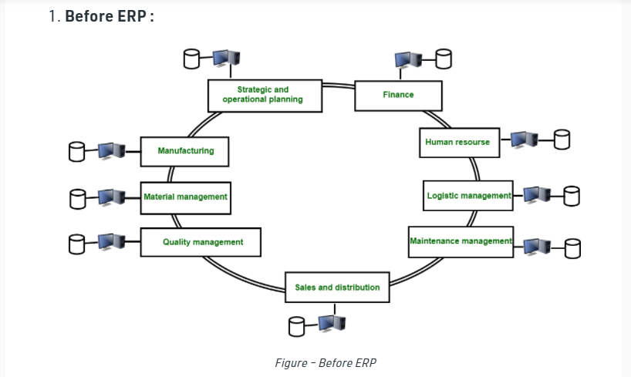

Before an ERP system, there are different databases of different departments which they managed by their own. The employees of one department does not know about anything about other department.
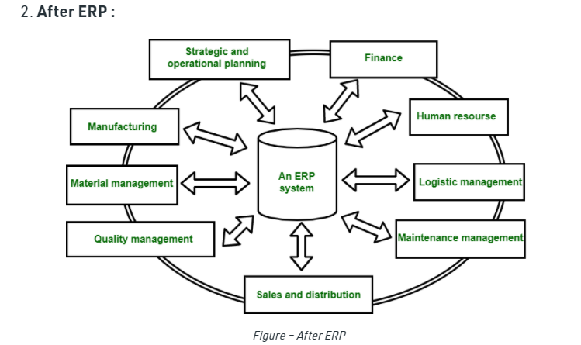
After ERP system, databases of different departments are managed by one system called ERP system. It keep tracks of all the database within system. In this scenario, employee of one department have information regarding the other departments.
Benefits of ERP :
- This system helps in improving integration.
- It is the flexible system.
- There are fewer errors in this system.
- This system improved speed and efficiency.
- There is a complete access to information.
- Lower total costs in complete supply chain.
- This system helps in Shortening the throughput times.
- There is sustained involvement and commitment of the top management
Limitations of ERP :
ERP system has 3 significant limitations :
- Managers generate custom reports or queries only with the help from a programmer and this will create a problem that they did not receive information quickly, which is essential for making a competitive advantage.
- There is no proper decision-making scenario i.e. this systems provide only the current status, such as open orders. Whenever there is need to look for past status to find trends and patterns it become difficult.that aid better decision-making.
- No doubt that data is integrated within the system, but there is no integration of data with other enterprise or division systems and it does not include external intelligence.

Cloud Service Components:
To the basic, cloud computing is referred as data storage, type of software outsourcing and processing. Software outsourcing consists of networking, servers, analytics, storage, databases, software and intelligence through the Internet. This delivers enhanced innovation, adaptable resources, and economic scalability. Through the internet connection, users can log in and gain accessibility for files and applications. Programs and data are hosted by external parties and accommodate it on the global network of protected data locations rather than storing in the user’s external components such as pen drive, hard disk, and others. This endorses for power management, simplifies data sharing and shows the path for easy mobile access irrespective of asking user details. So, this is an efficient method of providing computing resources.
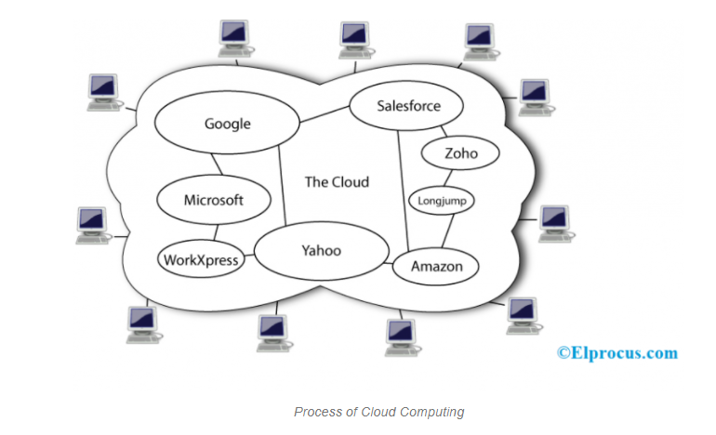

Cloud Computing Basics
The approach of cloud computing is in every aspect these days. Either small-scale, mid-scale or large-scale, every organization is implementing cloud computing methodologies for data storage, disaster recovery, software development, testing, big data analytics, virtual desktops, software deliveries, and web applications.
Streamlining many approaches, this computing has modernized the approaches of:

Maintaining Huge Servers
With the methodologies of cloud computing, there is no need to maintain huge servers in large equipment rooms.

Enhanced Data Storage
People can skip the approach of manually storing their information in hard discs, pen drives or any other external devices.

Restricted Geographic Accessibility
This technology offers the feature of gaining accessibility for processes and data at every location. So, this flexibility enhances the operation and performance of the next step.

Loss of Data
One might be worried about their data loss because of rapid enhancements in the hacking technology and it becomes so easy to steal the data. But the computing has shown a complete advancement in data protection where information is stored in cloud ad has numerous safeguards.
No mess up in sharing of documents with one other, because cloud-dependent files having shared accessibility are always up to date. So, there is no scope of file misplace or duplicate version of documents.

Components in Cloud Computing
Cloud computing components correspond to platforms such as front end, back end, and cloud-dependent delivery and the utilized network. So, a framework of cloud computing is broadly categorized as three specifically clients, distributed servers and datacentre.
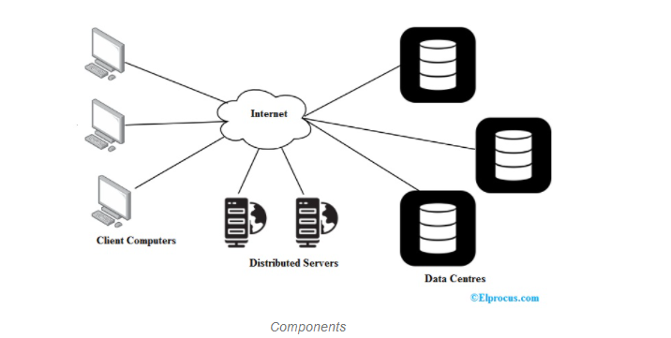 For the operation of this computing, the following three components have a big hand and the responsibilities of these components can be elucidated clearly as below:

Clients
Clients in cloud computing are in general to the operation of Local Area Networks (LAN’s). They are just the desktops where they have their place on desks. These might be also in the form of laptops, mobiles, tablets to enhance mobility. Clients hold the responsibility of interaction which pushes for the management of data on cloud servers.

Datacentre
It is an array of servers that houses the subscribed application. Progressing the IT industry has brought the concept of virtualizing servers, where the software might be installed through the utilization of various instances of virtual servers. This approach streamlines the process of managing dozens of virtual servers on multiple physical servers.

Distributed Servers
These are considered as a server where that is housed in the other location. So, the physical servers might not be housed in a similar location. Even the distributed server and the physical server appear to be in different locations, they perform as they are so close to each other.
While the other component is Cloud Applications, where it is defined as cloud computing in the form of software architecture. So, cloud applications serve as a service which operates both the hardware and software architecture.
Cloud service/Deployment Models
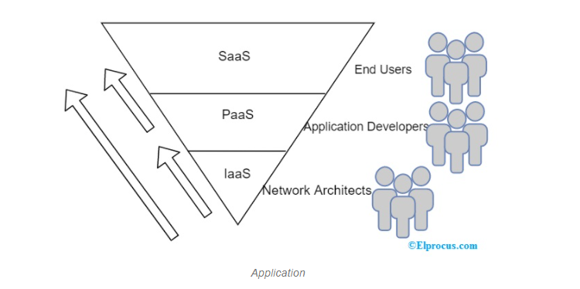 Further, cloud computing has many other components and those come under mainly as four classifications and these components are the services of cloud computing and they can be described as follow:

Infrastructure as a Service (IaaS)
The fundamental classification of cloud computing services. This service allows for the rent of servers and virtual systems, networks, IT infrastructure and storage too. It avoids the complication behind acquiring and administering own physical servers and infrastructure. Few of the business aspects offered by IaaS are:
- Economical web hosting services
- Supports application and web servers and manage networking resources
- Increased performance on computing
- Assists in big data analysis
- Maintains huge storage, backup, and recovery

Platform as a Service (PaaS)
So, this is the one service offering an on-demand atmosphere for development, testing, deployment of many software applications. It serves as a cloud deployment environment that maintains servers, and this enables the delivery of both simple cloud applications and complex enterprise applications. Few of the business aspects offered by PaaS are:
- Stands as a platform for the development and customization of cloud-based applications.
- PaaS tools allow you to investigate and mine their information thus finding deeper insights to deliver better outcomes.
- Offers services for enhanced protection, workflow, directory, and scheduling.

Software as a Service (SaaS)
This is the approach to deliver software applications over the Internet and it might be on-demand or through a subscription basis. It allows individuals to get connected and utilize cloud applications through the Internet. SaaS offers the feature of enhancement and operation of application at a reduced cost. Few of the business aspects offered by SaaS are:
- Shows simple accessibility for complex applications
- Allows using client software in a free manner
- Mobilize workforce
- Accessibility for application information from any location
So, the other services/components of cloud computing are:
- Cloud Clients
- Cloud Services
- Cloud Applications
- Cloud Platform
- Cloud Storage
- Cloud Infrastructure

Cloud Computing Architecture
As cloud computing is more prominent in today’s digitized world, one has to be clear about its architecture. So, cloud computing architecture exactly corresponds to multiple components and sub-components that develop the entire system structure.

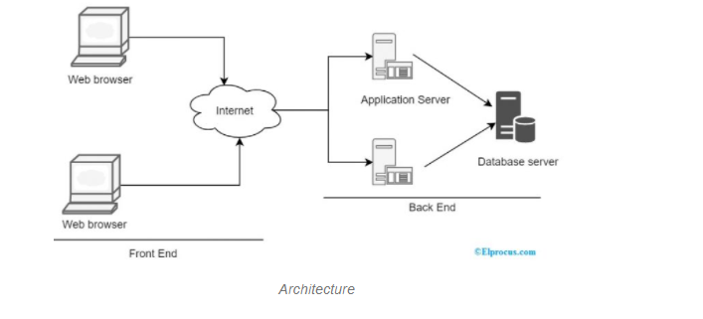 Cloud computing architecture comprises of two components:
- Front-End
- Back-End
Front-end corresponds to the client-side of cloud computing. This component is all about interfaces, applications and network those allow accessibility for a cloud system. The thing that has to be clear in this aspect is that not all the entire computing systems will work as a single interface.
Whereas back-end corresponds to the resources utilized by cloud computing servers. This component mainly deals with servers, security scenarios, virtualizing, data storage and many others. Also, back-end holds the responsibility to reduce traffic congestion mechanisms, and protocols that establish communication. Here, the operating system is termed as the bare metal server which is prominent with the name “hypervisor” where it utilizes well-defined protocols that allow for concurrent operation of numerous guest virtual servers. Hypervisor acts as a communication interface between its containers and for the connected world.
Apart from these, cloud-based delivery and cloud services network are also considered as cloud computing architecture. Delivery of cloud services can be done either publicly or privately through the internet. In a few cases, enterprises make use of both scenarios to deliver their services.

Advantages
In addition to delivering advantageous IT services to the current technology, this computing even shows multiple benefits for the organizations and those are:

Economical
This technology eliminates spending of huge expenses on buying hardware and software services, set up and operating external data centers. Even it minimizes the cost required for maintenance of power, storage space for servers and infrastructure.

Enhanced Scalability
Mostly, organizations with a heavy workforce face the problem of scalability. So, the cloud serves as the best solution to remove this complexity as it enables organizations to work quickly and efficiently in line with the business requirements. Cloud solutions are quintessential to meet with progressing demands. This means that when business demands enhance, cloud capacity can be easily increased without spending much. So, this level of scalability easily reduces complications.

Data Security
The most annoying problem these days for every organization is data security. Cybercrimes easily show the path for destroying an organization’s budget, secured information, and brand image.
So, to stay back from these breaches, cloud computing offers multiple secured features that ensure data protection and management. This makes sure to offer enhanced authentication, encryption and access control for data security.

Control
Being control over confidential information is crucial for every organization. Cloud allows you to have entire visibility and command over your information.
Furthermore, this technology also delivers other benefits like
- Enhanced performance
- Increased mobility and
- Speed
Thus, this is all about an overview of cloud computing. Moving in line with the current technological trends, cloud computing is implemented in many of the organizations and they gain more benefits through the implementation of this. The architecture of this enables for higher bandwidth and can be easily accessible. Get the idea of what are the emerging trends in cloud computing and digital forensics in the cloud?

Cloud components Guiding Principle with respect to utilization/Security/Pricing

Design Principles
There are six design principles for security in the cloud:

Implement a strong identity foundation:
Implement the principle of least privilege and enforce separation of duties with appropriate authorization for each interaction with your AWS resources. Centralize privilege management and reduce or even eliminate reliance on long term credentials.

Enable traceability:
Monitor, alert, and audit actions and changes to your environment in real time. Integrate logs and metrics with systems to automatically respond and take action.

Apply security at all layers:
Rather than just focusing on protecting a single outer layer, apply a defense-in-depth approach with other security controls. Apply to all layers, for example, edge network, virtual private cloud (VPC), subnet, load balancer, every instance, operating system, and application.

Automate security best practices:
Automated software-based security mechanisms improve your ability to securely scale more rapidly and cost effectively. Create secure architectures, including the implementation of controls that are defined and managed as code in version-controlled templates.

Protect data in transit and at rest:
Classify your data into sensitivity levels and use mechanisms, such as encryption and tokenization where appropriate. Reduce or eliminate direct human access to data to reduce risk of loss or modification.

Prepare for security events:
Prepare for an incident by having an incident management process that aligns to your organizational requirements. Run incident response simulations and use tools with automation to increase your speed for detection, investigation, and recovery.

Definition There are five best practice areas for security in the cloud:
- Identity and Access Management
- Detective Controls
- Infrastructure Protection
- Data Protection
- Incident Response
Before you architect any system, you need to put in place practices that influence security. You will want to control who can do what. In addition, you want to be able to identify security incidents, protect your systems and services, and maintain the confidentiality and integrity of data through data protection.
You should have a well-defined and practiced process for responding to security incidents. These tools and techniques are important because they support objectives such as preventing financial loss or complying with regulatory obligations.
The AWS Shared Responsibility Model enables organizations that adopt the cloud to achieve their security and compliance goals. Because AWS physically secures the infrastructure that supports our cloud services, as an AWS customer you can focus on using services to accomplish your goals.

Best Practices Identity and Access Management
Identity and access management are key parts of an information security program, ensuring that only authorized and authenticated users are able to access your resources, and only in a manner that is intended. For example, you should define principals (users, groups, services, and roles that take action in your account), build out policies aligned with these principals, and implement strong credential management.
These privilege-management elements form the core concepts of authentication and authorization. In AWS, privilege management is primarily supported by the AWS Identity and Access Management (IAM) service, which allows you to control user access to AWS services and resources. You should apply granular policies, which assign permissions to a user, group, role, or resource. You also have the ability to require strong password practices, such as complexity level, avoiding re-use, and using multi-factor authentication (MFA).
You can use federation with your existing directory service. For workloads that require systems to have access to AWS, IAM enables secure access through instance profiles, identity federation, and temporary credentials. The following questions focus on identity and access management considerations for security
SEC 1: How are you protecting access to and use of the AWS account root user credentials?
SEC 2: How are you defining roles and responsibilities of system users to control human access to the AWS Management Console and API?
SEC 3: How are you limiting automated access to AWS resources (for example, applications, scripts, and/or third-party tools or services)?
It is critical to keep root user credentials protected, and to this end AWS recommends attaching MFA to the root user and locking the credentials with the MFA in a physically secured location. IAM allows you to create and manage other non-root user permissions, as well as establish access levels to resources.

Detective Controls:
You can use detective controls to identify a potential security incident. These controls are an essential part of governance frameworks and can be used to support a quality process, a legal or compliance obligation, and for threat identification and response efforts. There are different types of detective controls.
For example, conducting an inventory of assets and their detailed attributes promotes more effective decision making (and lifecycle controls) to help establish operational baselines. Or you can use internal auditing, an examination of controls related to information systems, to ensure that practices meet policies and requirements and that you have set the correct automated alerting notifications based on defined conditions. These controls are important reactive factors that can help your organization identify and understand the scope of anomalous activity.
In AWS, you can implement detective controls by processing logs, events, and monitoring that allows for auditing, automated analysis, and alarming. CloudTrail logs, AWS API calls, and CloudWatch provide monitoring of metrics with alarming, and AWS Config provides configuration history. Service-level logs are also available, for example, you can use Amazon Simple Storage Service (Amazon S3) to log access requests. Finally, Amazon Glacier provides a vault lock feature to preserve mission-critical data with compliance controls designed to support auditable long-term retention.
The following question focuses on detective controls considerations for security.
SEC 4: How are you capturing and analyzing logs? Log management is important to a well-architected design for reasons ranging from security or forensics to regulatory or legal requirements.
It is critical that you analyze logs and respond to them so that you can identify potential security incidents. AWS provides functionality that makes log management easier to implement by giving you the ability to define a data-retention lifecycle or define where data will be preserved, archived, or eventually deleted. This makes predictable and reliable data handling simpler and more cost effective.

Infrastructure Protection
Infrastructure protection includes control methodologies, such as defense in depth and MFA, which are necessary to meet best practices and industry or regulatory obligations. Use of these methodologies is critical for successful ongoing operations either in the cloud or on-premises. In AWS, you can implement stateful and stateless packet inspection, either by using AWS-native technologies or by using partner products and services available through the AWS Marketplace.
You should use Amazon Virtual Private Cloud (Amazon VPC) to create a private, secured, and scalable environment in which you can define your topology—including gateways, routing tables, and public and private subnets. The following questions focus on infrastructure protection considerations for security.
Infrastructure protection includes control methodologies, such as defense in depth and MFA, which are necessary to meet best practices and industry or regulatory obligations. Use of these methodologies is critical for successful ongoing operations either in the cloud or on-premises. In AWS, you can implement stateful and stateless packet inspection, either by using AWS-native technologies or by using partner products and services available through the AWS Marketplace.
You should use Amazon Virtual Private Cloud (Amazon VPC) to create a private, secured, and scalable environment in which you can define your topology—including gateways, routing tables, and public and private subnets. The following questions focus on infrastructure protection considerations for security.
SEC 5: How are you enforcing network and host-level boundary protection?
SEC 6: How are you leveraging AWS service-level security features?
SEC 7: How are you protecting the integrity of the operating system?
Multiple layers of defense are advisable in any type of environment. In the case of infrastructure protection, many of the concepts and methods are valid across cloud and on-premises models. Enforcing boundary protection, monitoring points of ingress and egress, and comprehensive logging, monitoring, and alerting are all essential to an effective information security plan.
AWS customers are able to tailor, or harden, the configuration of an Amazon Elastic Compute Cloud (Amazon EC2), Amazon EC2 Container Service (Amazon ECS) container, or AWS Elastic Beanstalk instance, and persist this configuration to an immutable Amazon Machine Image (AMI). Then, whether triggered by Auto Scaling or launched manually, all new virtual servers (instances) launched with this AMI receive the hardened configuration.

Data Protection
Before architecting any system, foundational practices that influence security should be in place. For example, data classification provides a way to categorize organizational data based on levels of sensitivity, and encryption protects data by rendering it unintelligible to unauthorized access. These tools and techniques are important because they support objectives such as preventing financial loss or complying with regulatory obligations.

In AWS, the following practices facilitate protection of data:
As an AWS customer you maintain full control over your data.
AWS makes it easier for you to encrypt your data and manage keys, including regular key rotation, which can be easily automated by AWS or maintained by you. Detailed logging that contains important content, such as file access and changes, is available. AWS has designed storage systems for exceptional resiliency. For example, Amazon S3 is designed for 11 nines of durability. (For example, if you store 10,000 objects with Amazon S3, you can on average expect to incur a loss of a single object once every 10,000,000 years.)
Versioning, which can be part of a larger data lifecycle management process, can protect against accidental overwrites, deletes, and similar harm. AWS never initiates the movement of data between Regions. Content placed in a Region will remain in that Region unless you explicitly enable a feature or leverage a service that provides that functionality. The following questions focus on data protection considerations for security.
SEC 8: How are you classifying your data?
SEC 9: How are you encrypting and protecting your data at rest?
SEC 10: How are you managing keys?
SEC 11: How are you encrypting and protecting your data in transit?
AWS provides multiple means for encrypting data at rest and in transit. AWS build features into our services that make it easier to encrypt your data. For example, AWS has implemented server-side encryption (SSE) for Amazon S3 to make it easier for you to store your data in an encrypted form. You can also arrange for the entire HTTPS encryption and decryption process (generally known as SSL termination) to be handled by Elastic Load Balancing (ELB).

Incident Response
Even with extremely mature preventive and detective controls, your organization should still put processes in place to respond to and mitigate the potential impact of security incidents. The architecture of your workload will strongly affect the ability of your teams to operate effectively during an incident to isolate or contain systems and to restore operations to a known-good state.
Putting in place the tools and access ahead of a security incident, then routinely practicing incident response, will make sure the architecture is updated to accommodate timely investigation and recovery. In AWS, the following practices facilitate effective incident response:
Detailed logging is available that contains important content, such as file access and changes. Events can be automatically processed and trigger scripts that automate runbooks through the use of AWS APIs.
You can pre-provision tooling and a “clean room” using AWS CloudFormation. This allows you to carry out forensics in a safe, isolated environment. The following question focuses on incident response considerations for security
SEC 12: How do you ensure that you have the appropriate incident response?
Ensure that you have a way to quickly grant access for your InfoSec team, and automate the isolation of instances as well at the capturing of data and state for forensics.

Key AWS Services
The AWS service that is essential to security is IAM, which allows you to securely control access to AWS services and resources for your users. The following services and features support the five areas in security:

Identity and Access Management:
IAM enables you to securely control access to AWS services and resources. MFA adds an extra layer of protection on top of your user name and password.

Detective Controls:
AWS CloudTrail records AWS API calls, AWS Config provides a detailed inventory of your AWS resources and configuration, and Amazon CloudWatch is a monitoring service for AWS resources.

Infrastructure Protection:
Amazon VPC lets you provision a private, isolated section of the AWS Cloud where you can launch AWS resources in a virtual network.

Data Protection:
Services such as ELB, Amazon Elastic Block Store (Amazon EBS), Amazon S3, and Amazon Relational Database Service (Amazon RDS) include encryption capabilities to protect your data in transit and at rest. Amazon Macie automatically discovers, classifies, and protects sensitive data, while AWS Key Management Service (AWS KMS) makes it easy for you to create and control keys used for encryption.
Incident Response: IAM should be used to grant appropriate authorization to incident response teams. AWS CloudFormation can be used to create a trusted environment for conducting investigations.

Cloud Computing Applications with Use Cases (Advanced)
In our last session, we talked about Cloud Computing Features. Here, we will discuss Cloud Computing applications. Along with this, we will learn some Cloud Computing use cases.
So, let’s start exploring Cloud Computing applications with use cases.

Cloud Computing Applications
Cloud Computing can run every programs and software as a normal computer can run. It can also provide us with numerous applications which are free of cost. So, let’s start elaborating these Cloud Computing applications one by one:

i. Storing File Online

Cloud Computing provides a benefit to store and access the software with the help of internet connection to the Cloud. The interface provided is very easy to operate and is economical too.

ii. Video Making and Editing Software
There are many software available which can access with the help of the cloud. This software helps to create and modify the videos. The videos create or modify are stored in the cloud itself and we can access anytime.

iii. File Converters
There are many applications which utilize to change to format of the file such that from HTML to pdf and so on. This software is available at cloud and access from anywhere with the help of internet connection.

iv. Anti-Virus Applications
There is software which is stored in the cloud and from there they fix the system. All the viruses and the malware are detected and analyzed by the software and the system is fixed. They also come up with a feature of downloading the software.

v. E-commerce Application
With the help of e-commerce application in the cloud, user and e-business allow responding quickly to the opportunities which are emerging. It also allows the user to respond quickly to the market opportunities and the challenges.
Business tycoons focuse on the usage of cloud computing without keeping time in the mind. Cloud-based e-commerce applications allow the companies, business leaders to evaluate new opportunities and making things done with the minimum amount possible.

vi. Business Process
Business management applications are based on the cloud service provider. The business utilizes the cloud computing to store the necessary data and all the relevant information. This information can be anything such as the personal data of the customer, analyzed records, and many more.

vii. Backup and Recovery
The cloud computing can be used as a backup option in which we can store the files, information, and the data. This data is stored will be protected and provided much security. When the data is lost the user can recover the data which he/she has stored in the cloud.

Cloud Computing Use Cases
After studying Cloud Computing Applications, its time to explore its use cases.

. Private Cloud and Hybrid Cloud
There are situations where the firms are searching for the ways through which they can find a way to access the applications they intend to deploy into their environment through the use of a cloud.
This leads to the fact that providing the facilities without the initial investment will be rendered useless and the workload testing fails.

ii. Big Data Analysis
Cloud Computing can store a tremendous amount of data which can also help Big Data. Big Data, a large amount of data (structured or unstructured) is analyzed for further analysis or for decision making in the business.

iii. Disaster Recovery
Disaster Recovery is one of the major benefits which gathers from Cloud Computing. It provides an economical way from the disaster recovery as there is a solution which provides a faster recovery from the congested different physical locations.
The traditional DR sites can cost much of the amount which has fixed assets, tough productions, and a much higher cost.

iv. Iaas and PaaS
While using Infrastructure as a service there is a pay as you go through the scheme available. It benefits the companies and organizations by cutting the cost of investing to maintain the IT infrastructure.
Moreover, there is an instance where the companies using Platform as a Service searching to increase the speed of development on a ready-to-use platform to deploy applications.
So, this was all about Cloud Computing Applications and its use cases. Hope you found this helpful.

Public Cloud Platforms and its usage
The public cloud is a range of computing services that are offered by platforms such as Amazon Web Services (AWS), Microsoft Azure, and Google Cloud Platform (GCP) and making them available over the internet. They are readily accessible to all that want to use and/or purchase them.
Choosing the right public cloud provider is becoming an increasingly nuanced discussion that goes well beyond scale. There are three major players in the public cloud platforms arena - Amazon Web Services (AWS), Microsoft's Azure, and Google Cloud Platform. The top cloud computing companies are addressing a large and growing market. In turn, they provide a wide array of cloud-related products and services, including infrastructure-as-a-service (IaaS), platform as a service (PaaS), and software-as-a-service solutions (SaaS).
This learning path provides you with an overview of the three platforms and then takes a closer look at each. By looking at the three platforms together, you will be able to see what the strengths and weaknesses of each are, how they align with your larger goals, as well as get a sense of where the industry is heading as a whole.
For individuals and organizations looking for a deeper understanding of the cloud computing space, or some direction for which platform to dive deeper into depending on the direction you are looking to head, this is a great starting point.

Learning Objectives
- Obtain a baseline understanding of the three main cloud vendors on the market today: AWS, Azure, and GCP
- Learn about their core features and capabilities

Intended Audience
This learning path is ideal for anyone looking to learn more about the cloud and cloud computing.

Prerequisites
Since this is an introductory-level learning path there are no prerequisites, however, we would recommend having an interest in cloud computing.

FAQs
What is the difference between a public cloud and a private cloud?
The key differentiator between the two clouds is that with public clouds you don’t have to worry about managing the hosting solution. Your data is housed on the host’s data center, which makes the provider responsible for maintaining the data center.
What is the difference between public, private, and hybrid clouds?
Public clouds are managed and maintained by a cloud vendor. These clouds may be free or subscription-based. Private clouds are managed and maintained by your company. The initial cost of setting up a private cloud can often be cost-prohibitive. A hybrid cloud is a blend of both private and public. Hybrids may use the private portion may be used for housing secure data or IT workloads, and then use the public portion to offset the sporadic spikes in network traffic.
What is AWS cloud?
Amazon Web Services (AWS) is a secure cloud service similar to a private cloud, yet it offers many of the benefits of a public cloud including additional compute power, storage for your data, and other functionality designed to help your business grow without the costs of creating a true private cloud.
What is the difference between Azure and AWS?
AWS offers multiple functionalities and is a more seasoned solution for your cloud needs. While many of these functions add overall cost to use, they are enterprise-friendly for larger organizations. Azure offers a solid hybrid cloud solution for those companies looking to offset some of the network traffic while still keeping things very secure.
What is the difference between IaaS and PaaS?
Infrastructure as a Service (IaaS) is the basic level. It provides pre-configured systems via an interface or hypervisor. The next step up is Platform as a Service (PaaS), which includes the operating system and applications. This type of service is attractive to companies looking to create applications in a specific environment, while not being required to maintain the platform.

Conclusion
Cloud Computing has provided many solutions which are useful for companies as well as individuals. The Cloud Computing helps by providing the solutions in the minimum cost possible.
Cloud Computing has many examples which can be in the field of everything such as messaging apps, audio, and video service.

